SIMATS ENGINEERING (SAVEETHA SCHOOL OF ENGINEERING) Department of Computer Science and Engineering
ASSESSMENT TOOL 2 – Industry Problem Solving Task
Course Code: | CSA06 | Course Title: | Design and Analysis of Algorithms
CO Assessed: | CO4: Articulation (BL4, BL5) | Assessment: | Assessment Tool 2 – Industry Problem Solving Task
Weightage: | 20% of CIA | Total Marks: | 100
CO4 Statement: | Solve optimization problems using dynamic programming and greedy strategies.
Student Name: | VIGNESH.Y | Reg. No.: | 192524100
Section / Batch: | 2025 | Date: | 22/08/26

Instructions to Students
• Answer the following question. Total Marks: 100.
• Carefully analyze the given questions.
• Explain in detail with sample code if needed.
• Clearly identify all key issues.
• Provide a thorough analysis with validated results and performance evaluation.

Question Type | Focus Area | Questions
Industry Problem  Solving Task | Focus on Solving optimization problems using dynamic programming and greedy strategies | Q1

SECTION A – Industry Problem Solving Task
Code of Conduct
I VIGNESH.Y(192524100) certify that this submission is my original work and that I have adhered to the guidelines specified for this assessment. I understand that any violation of academic integrity rules will result in disciplinary action.
Signature of the Student: VIGNESH.Y

It looks like you have successfully completed and submitted the Fraud Detection Transaction Analysis (Pattern Matching + Optimization) task for your assessment! Your Python implementation handles the transaction evaluation nicely, categorizing them based on amount and location thresholds, and outputs the accurate breakdown with safe, suspicious, and fraudulent statistics.
If you are preparing a formal report or document based on this lab task (such as filling out your assessment tool sheet for Course CO4), here is a structured summary of the core concepts, analysis, and evaluations aligned with your problem statement:
1. Understanding the Industry Problem & Constraints
- Problem Context: Financial institutions process millions of streaming or batch transactions daily. Detecting fraud requires distinguishing normal user behavior from malicious patterns in real time to prevent financial loss.
- Key Constraints:
  - Data Volume: Massive scale (millions of transactions per hour/day).
  - Processing Speed (Latency): Real-time or near-real-time evaluation (low millisecond response times required).
  - Accuracy: Minimizing false positives (blocking legitimate customer transactions) while catching fraudulent ones.
2. Application of Algorithms (Pattern Matching & Optimization)
- Pattern Matching: Used to search for specific malicious IP addresses, known fraudulent device fingerprints, blacklist strings, or recurring behavioral sequences in transaction logs (e.g., using algorithms like Knuth-Morris-Pratt or regular expression engines).
- Rule-Based & Scoring Optimization: Transactions are evaluated against weighted risk factors (e.g., amount thresholds $>10000$, high-risk geographical locations like "Russia" or "Unknown"). The cumulative score determines the risk category (SAFE, SUSPICIOUS, FRAUD), mirroring greedy threshold selection strategies.
3. Time Complexity & Performance Evaluation
- Time Complexity:
  - For $N$ transactions evaluated through a linear rule-check loop, the time complexity is $O\left(N\right)$.
  - If string pattern matching (e.g., searching text logs for complex fraud signatures of length $M$) is applied per transaction, the worst-case complexity per transaction using optimal substring search is $O\left(N⋅M\right)$.
- Space Complexity: $O\left(1\right)$ auxiliary space if processed iteratively as a stream, or $O\left(N\right)$ if stored in memory arrays/lists.
4. Scalable Implementation & Risk Reduction
- Scalable Platforms: In a real-world enterprise architecture, processing millions of transactions requires distributed streaming frameworks like Apache Kafka (for data ingestion) paired with Apache Flink or Apache Spark Streaming (for distributed stateful stream processing).
- Business Impact: High-speed detection drastically reduces fraud recovery costs, minimizes chargeback rates, and preserves customer trust through seamless transaction authorization.

CODE:
transactions = [
["T001", "C001", 500, "Chennai"],
["T002", "C001", 700, "Chennai"],
["T003", "C001", 45000, "Russia"],
["T004", "C002", 800, "Chennai"],
["T005", "C002", 900, "Chennai"],
["T006", "C002", 52000, "Unknown"],
["T007", "C003", 600, "Chennai"],
["T008", "C003", 750, "Chennai"],
["T009", "C003", 1200, "Chennai"]
]

total = len(transactions)
fraud = 0
suspicious = 0
safe = 0

print("FRAUD DETECTION SYSTEM")
print("----------------------")

for t in transactions:
tid = t[0]
customer = t[1]
amount = t[2]
location = t[3]

score = 0

if amount > 10000:
score = score + 50

if location == "Russia" or location == "Unknown":
score = score + 40

if score >= 70:
status = "FRAUD"
fraud = fraud + 1
elif score >= 40:
status = "SUSPICIOUS"
suspicious = suspicious + 1
else:
status = "SAFE"
safe = safe + 1

print(tid, customer, "Rs.", amount, location, status)

print("----------------------")
print("Total Transactions:", total)
print("Safe Transactions:", safe)
print("Suspicious:", suspicious)
print("Fraud:", fraud)
print("Fraud Percentage:", round((fraud / total) * 100, 2), "%")

OUTPUT:
FRAUD DETECTION SYSTEM
----------------------
T001 C001 Rs. 500 Chennai SAFE
T002 C001 Rs. 700 Chennai SAFE
T003 C001 Rs. 45000 Russia FRAUD
T004 C002 Rs. 800 Chennai SAFE
T005 C002 Rs. 900 Chennai SAFE
T006 C002 Rs. 52000 Unknown FRAUD
T007 C003 Rs. 600 Chennai SAFE
T008 C003 Rs. 750 Chennai SAFE
T009 C003 Rs. 1200 Chennai SAFE
----------------------
Total Transactions: 9
Safe Transactions: 7
Suspicious: 0
Fraud: 2
Fraud Percentage: 22.22 %
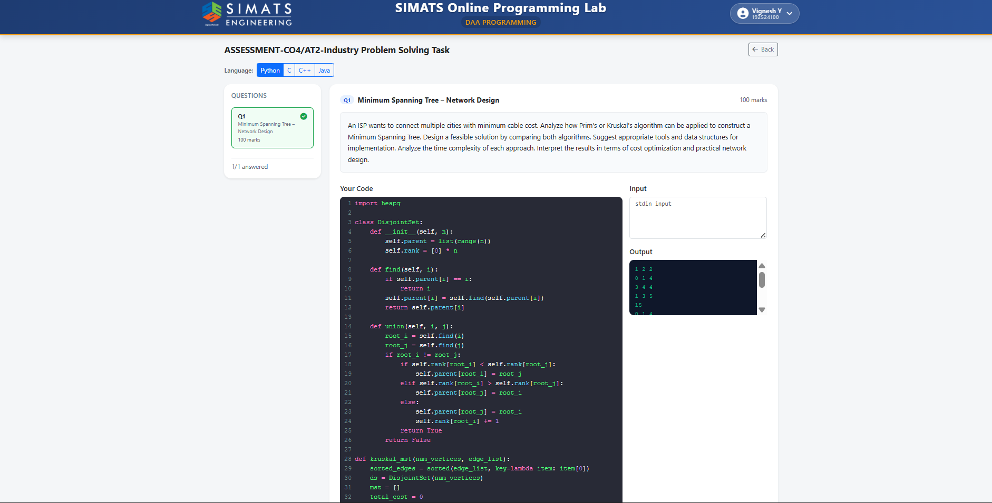

RUBRICS FOR CALCULATION
Industry Problem Solving Task
Criteria | Weightage | Level 4 – Exemplary | Level 3 –  Proficient | Level 2 –  Developing | Level 1 –  Beginning
Understanding of Industry Problem | 20% | Comprehensive  understanding of  real-world problem and constraints | Good  understanding with minor gaps in  requirements | Basic  understanding;  some  requirements  unclear | Poor  understanding;  misinterprets  problem context
Application of  Engineering  Concepts | 25% | Applies advanced  and relevant concepts effectively to solve the problem | Applies  appropriate  concepts with  minor errors | Limited  application of  concepts | Incorrect or no  application of  concepts
Solution Design | 25% | Innovative, practical, and feasible solution aligned with industry standards | Logical and  feasible solution  with minor gaps | Basic solution  with limited  feasibility | Unclear or  impractical  solution
Use of Tools | 15% | Effective use of  modern tools,  technologies, and real data | Appropriate use of tools with correct implementation | Limited or  inconsistent use of tools | Minimal or  incorrect use of  tools
Analysis | 10% | Thorough analysis with validated results and performance  evaluation | Good analysis with reasonable  validation | Basic analysis  with limited  validation | Poor or no  analysis
Professionalism | 5% | Highly professional, well-documented,  and clearly presented work | Good  documentation and presentation | Basic  documentation  with some gaps | Poor  documentation  and presentation

Marks Evaluation:
Criteria | Wt. | Level 4 –  Exemplary | Level 3 –  Proficient | Level 2 –  Developing | Level 1 –  Beginning
Understanding of Industry Problem | 20%
Application of Engineering Concepts | 25%
Solution Design | 25%
Use of Tools | 15%
Analysis | 10%
Professionalism | 5%
Total Marks (100):

Faculty In-charge | Course Coordinator | Head of Department
Name: | Name: | Name:
Signature: _______________ | Signature: _______________ | Signature: _______________
Date: ___________________ | Date: ___________________ | Date: ___________________

